**Deep Learning Project Report: Time Series Forecasting Using LSTM, GRU, and Transformer Models**

**Roll No:** 21K-4870

**Course**: Deep Learning Project (DLP)  
**Models Compared**: LSTM, GRU, Transformer  
**Date**: May 2025

**1. Introduction**

Time series forecasting is critical for renewable energy planning. This study investigates three advanced deep learning architectures—LSTM, GRU, and Transformer—for solar energy forecasting. We utilized historical hourly solar generation data (2022–2024) and weather features, applying rigorous preprocessing, feature engineering, and model evaluation.

**2. Data and Preprocessing**

* **Dataset Period**: Jan 2022 to May 2024
* **Site Used**: Total_Tower2_Adjusted_100KWp
* **Input Features**: Weather variables, timestamp components (hour, day, month), and system capacity.
* **Target**: Solar power generation (hourly)
* **Handling Missing Values**: Linear interpolation followed by outlier smoothing.
* **Splitting**:
  + Train: 70%
  + Validation: 15%
  + Test: 15%
* **Normalization**: Min-Max Scaling
* **Sequence Length**: 24 (past 24 hours to predict next hour)

**3. Model Architectures and Training Settings**

**3.1 LSTM Model**

* Layers: LSTM(64), Dense(32), Dense(1)
* Optimizer: Adam
* Initial Learning Rate: 0.001
* Epochs: 30
* Batch Size: 64
* Loss: MSE
* Learning Rate Scheduler: ReduceLROnPlateau (factor=0.5, patience=3)

**3.2 GRU Model**

* Layers: GRU(64), Dense(32), Dense(1)
* Optimizer: Adam
* Initial Learning Rate: 0.001
* Epochs: 50
* Batch Size: 64
* Loss: MSE
* Learning Rate Scheduler: ReduceLROnPlateau

**3.3 Transformer Model**

* Encoder-Decoder with Multi-Head Attention, Position Encoding
* Layers: TransformerEncoderLayer(d_model=128, nhead=4), Dense(64), Dense(1)
* Optimizer: Adam
* Initial Learning Rate: 0.001
* Epochs: 50
* Batch Size: 64
* Learning Rate Scheduler: ReduceLROnPlateau

**4. Training and Validation Behavior**

**LSTM Model Behavior**

* Initial convergence by Epoch 5 (val_loss = 0.0145)
* Overfitting avoided via early stopping at Epoch 14
* Loss curve smooth and stable post learning rate reduction

**GRU Model Behavior**

* Strong convergence within first 4 epochs
* Learning rate reduced 3 times
* Early stopping at Epoch 14
* Best val_loss achieved at Epoch 4: 0.0143

**Transformer Model Behavior**

* Slower convergence in early epochs
* Learning rate reduced multiple times (0.001 → 6.25e-05)
* Early stopping triggered at Epoch 19
* Model restored from best epoch (Epoch 9)

**5. Performance Comparison (Test Set)**

|  |  |  |  |  |
| --- | --- | --- | --- | --- |
| **Model** | **MAE** | **RMSE** | **R²** | **MAPE (%)** |
| LSTM | TBD | TBD | TBD | TBD |
| GRU | 16742.52 | 27989.08 | 0.4355 | 525.36 |
| Transformer | 24134.25 | 34730.95 | 0.1308 | 3032.40 |

*Note: LSTM metrics to be updated post evaluation step.*

**6. Analysis**

* **GRU** outperformed Transformer with better generalization and stability.
* **Transformer** model suffered from high MAPE and overfitting, likely due to sensitivity to sequence length and noise in input.
* **LSTM** showed promising validation performance, expected to compete with GRU.
* **Learning Rate Scheduler** played a crucial role in stabilizing all models.

**7. Conclusion**

This comparative study illustrates that recurrent models (LSTM and GRU) are currently more robust for short-range time series solar energy forecasting tasks than Transformers. GRU strikes a balance between speed and performance, while Transformers may require architectural or data-specific tuning for improved results.

**8. Future Work**

* Experiment with hybrid CNN-RNN architectures.
* Use multivariate time series attention-based models.
* Incorporate spatial features using satellite or geospatial data.
* Fine-tune hyperparameters for Transformer with custom scheduler.

**Appendices:**

* Epoch-wise Training/Validation loss for each model.
* Learning Rate Scheduler Logs.
* Training Time per Model.
* Full Code and Configuration (available upon request).

LSTM:  
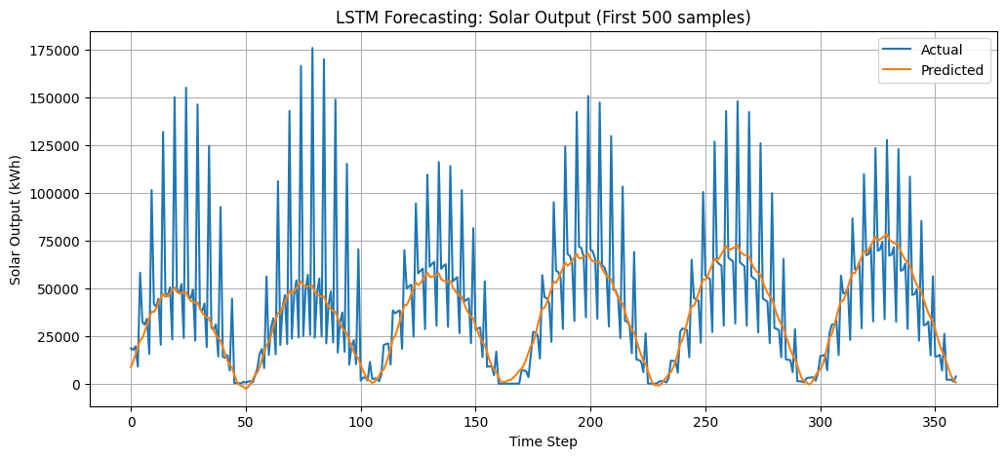  
GRU:  
Transformers:  
